Dear Sir,

We appreciate this opportunity and are pleased to offer a solution according to your request.

Design Criteria:

The following criteria are the base for the recommended equipment.

Required Airflow:

Coolant Liquid: Straight oil
- Contamination: Sticky black smoke

Inlet Load: MAX 70 Mg/m3

Type of Machine:

Miscellaneous (solid particles need…….):

Recommended Equipment

12002501 Absolent ODR-2000 Mist & Smoke Collector Price: $10.918.00
Configuration: Vertical

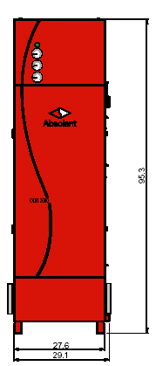
Motor: (1) 3.5 HP (Direct Drive Fan)
Dimensions: D 30.7 " x W 27.6" x H 95.3"
Inlet: 8.0”
Outlet: Top of the unit. Outlet connection accessory
Weight (Clean filters): 804 Lbs.
Air Volume: 1180 CFM
Noise Level: 57 dBA @ 3 Meters from Outlet Grille
Electrical: 230/460V, 3-Phase, 60Hz
Filtration: Fiber Bed 1: 123 Sq. Ft.
Fiber Bed 2: 146 Sq Ft
Absolute Filter: 219 Sq. Ft.
Filter access: Front Load Filter Accessibility (Door w. Hinges)
Drainage: Inlet Plenum w. Drain pipe (1.1/4”)
Gauges: Gauges/ 0-4": (3 Total)

Warranty and Guarantees
- Manufacturers Warranty: 1 year
- Guaranteed Filter Bed Lifetime: 1 year if load does not exceed recommended value by Absolent
- Separation degree: 99.97 %
- Washability of filters stage 1 & 2: None
- Expected lifetime due to references:

Terms
- Validity of quotation: 2 months from date issued
- Freight Terms: Ex works, Abslolent inventory, Norfolk VA
- Payment terms: 30 days net.

We hope…..

Best regards

