Dear Customer, Date:

We appreciate the opportunity and are pleased to offer Customer the following solution.

Design Criteria:

The following criteria are the base for the recommended equipment.

Required Airflow:

Contamination:

Inlet Load: Max 150 mg/m3 Oil smoke.

Type of Machine:
- Miscellaneous:

Absolent ODR-12000T Mist & Smoke Collector List Price: $Price on demand
Configuration: Vertical

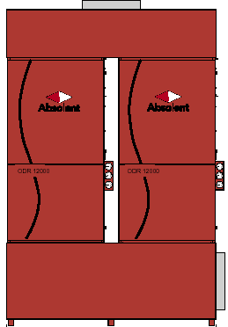
Motor/Blower: NOT INCLUDED
Dimensions: D 86.4" x W 89.3" x H 130.3"
Inlet: 26.0” (Bottom plenum left or right)
Outlet: 32.0” (Top plenum center or side)
Weight (Clean filters): 7600 Lbs.
Air Volume: 9400 CFM
Noise Level: ? dBA @ 3 Meters from Outlet Grille
Electrical: Not Included
Filtration: Fiber Bed 1: 1033 Sq. Ft.
Fiber Bed 2: 1098 Sq. Ft.
Absolute Filter: 2428 Sq. Ft.
Filter access: Front Load Filter Accessibility
Drainage: Inlet Plenum w. Drain
Start/Stop: Not included
Enclosure NEMA
Gauges: Magnehelic Gauges/ 0-10": (6 Total)

Note! The ODR 12000 comes in modules and has to be assembled at customer site!!!!!!
When ordering please inform at what side inlet flange, outlet flange shall be placed.

Delivery cost: (Ex-works Sweden to Norfolk, no discount) Fixed cost: by quote

Warranty and Guarantees
- Manufacturers Warranty: 1 year
- Guaranteed Filter Bed Lifetime: 1 year if load does not exceed recommended value by Absolent
- Separation degree: 99.97 %
- Washability of filters stage 1 & 2: None
- Expected lifetime due to references:

Terms
- Validity of quotation: 2 months from date issued
- Freight Terms: Ex Works Sweden to Norfolk VA
- Payment terms: 30 days net

