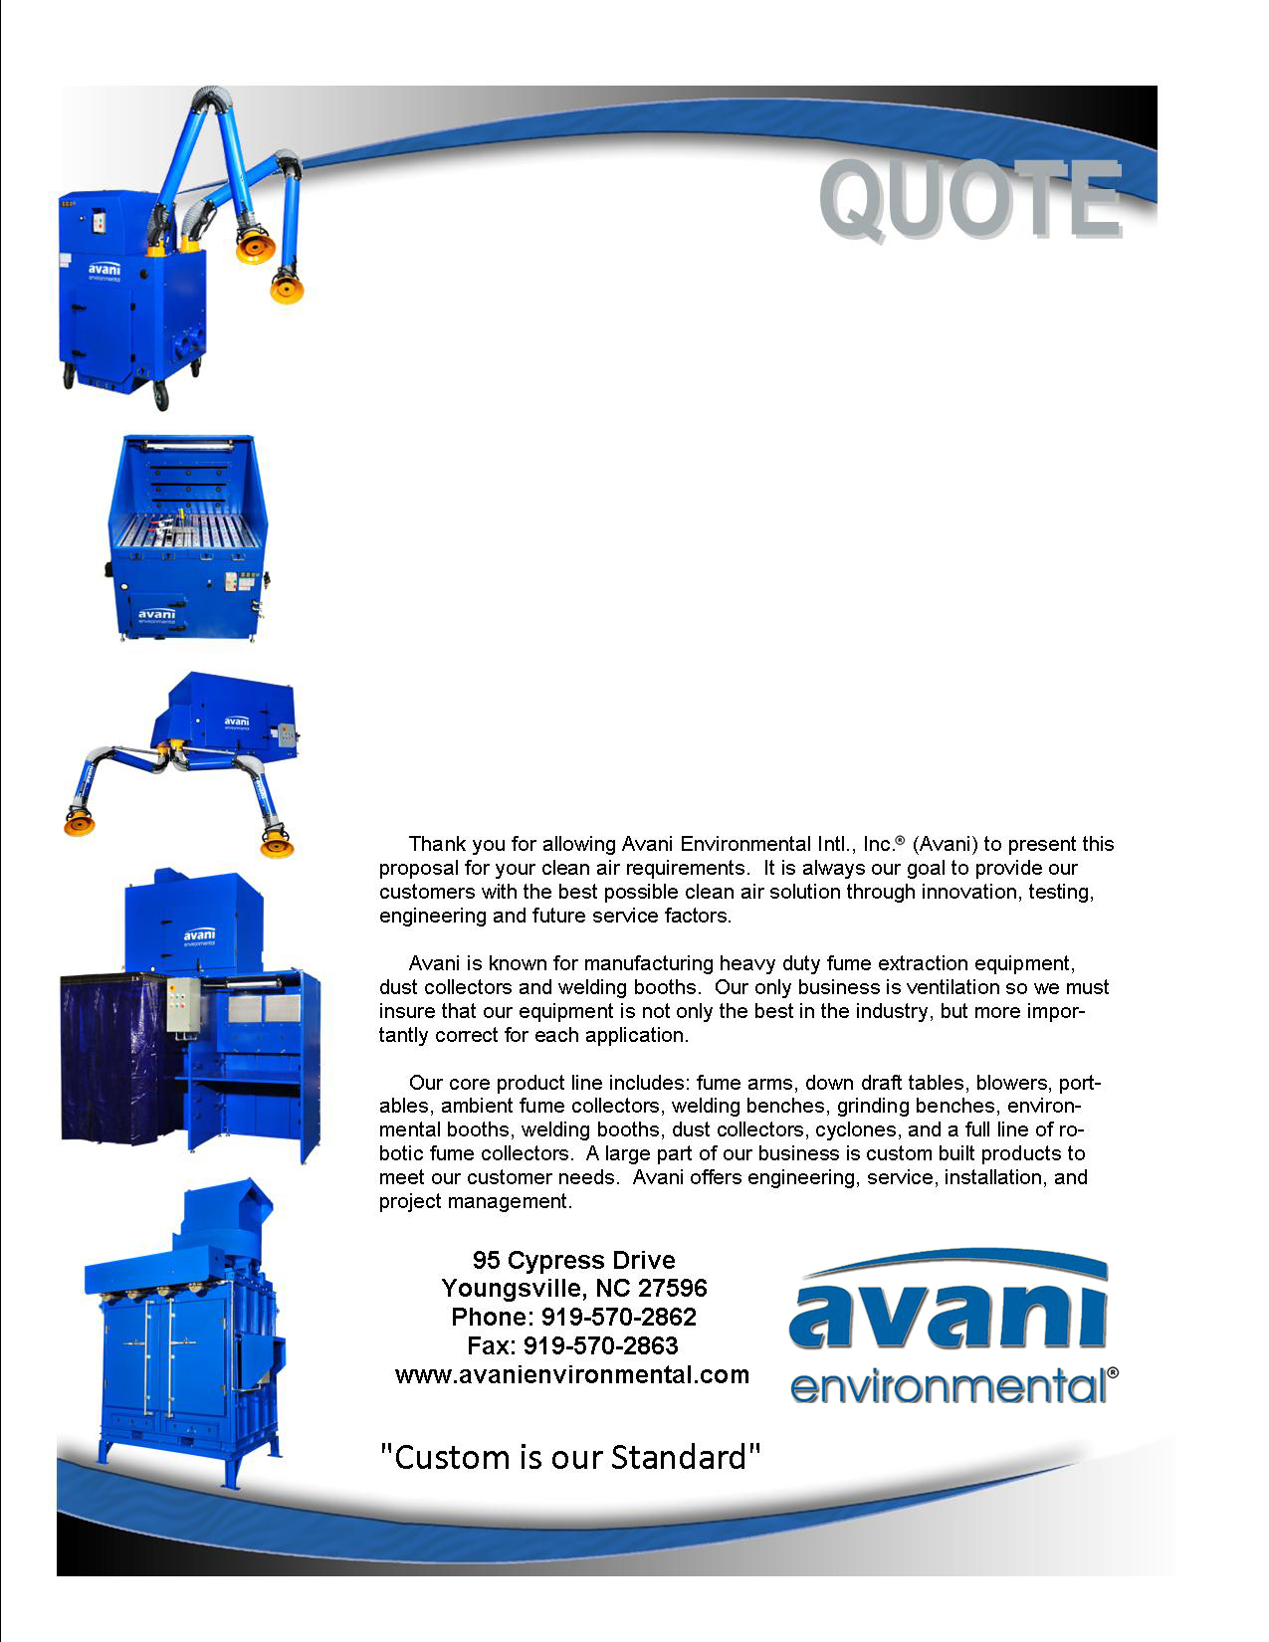

Attn: Jeffery Bergeron

Bartlett-Cocke General Contractors

**Job Name: Lee College**

**Quote #: AE-010924-REV-2**

Quote by: **Kirke Blenkhorn; Educational Sales**

**(for Richard King; Territory Manager, TX)**

**E-Mail:**

rking@avanienvironmental.com

education@avanienvironmental.com

**December 30, 2014**

**Avani Environmental Intl., Inc.®**

**95 Cypress Drive**

**Youngsville**, **NC 27596**

Phone: 919-570-2862 Fax: 919-570-2863

**Quote #: AE-010924-REV-1 December 30, 2014, Quote by: Education Sales**

Attn: Jeffery Bergeron; Ph: 713-996-9510, (M): 512-351-6740, E-Mail: jbergeron@bartlettcocke.com

**Bartlett-Cocke General Contractors**

**4540 Kendrick Plaza, # 120, Houston, TX 77032**

Site Address: Lee College, 511 South Whiting, (P.O. Box 818), Baytown, TX 77522

Jeffery; Please find the revised quote requested:

|  |  |  |  |  |  |  |  |
| --- | --- | --- | --- | --- | --- | --- | --- |
| **Product Name** | **Product Description** | **Product Picture** | | **Quantity** | | **Unit Price** | **Total Price** |
| SPC-2807 | SPC-2807: Portable Filtration Unit. Powder coated steel, casters, starter, reverse jet pulse, and clean out drawers.  Electrical: 1.5-HP high efficiency motor, 120/1/60, 1-phase  CFM: 1100  Lifetime Guarantee offered on this unit.  Fume Arm Configuration: 8"dia x 7' fume arm (2020P)  Filtration: 3-stages: Spark Trap, cartridge, and Carbon  ***Optional HEPA and other filter media available*** |  | | 1 | | $4,579.00 | $4,579.00 |
| WB-1056 | Welding Booth: Avani 1000 Series Model WB-1056  Dimensions: 60" W x 72" D x 90" H  Support Structure: 2"x2" Welded Square stock  Panel Contruction: 12-guage welded steel with 1" welded square stock cross and bracing.  Welding Curtain Bar with Brackets  Fixed Rear Shelf; 60” W x 18” D  Adjustable Feet, Powder Coated Avani Safety Blue, 3 piece construction. |  | | 90 | | $1,801.00 | $162,090.00 |
| Avani Welding Curtains | Welding Curtains for WB-1056; 1-Ply, Poly Material, 6’ W x 5’ H, Color: Dark Blue |  | | 90 | | $99.00 | $8,910.00 |
| ARM 1620 | Industrial fume arm c/w external adjustment friction joints, tension spring w/safety cover, inline volume control damper, source capture hood w/deflector, flexible hose joints, powder coated steel tube sections, handle, perimeter grab handle, dimensions 6”D x 7’L w/13”Dia hood. |  | | 90 | | $636.00 | $57,240.00 |
| LK-100x | Light Kit - 100V, 35 watt Halogen Light with swith. |  | | 90 | | $91.00 | $8,190.00 |
| BR 006 | Heavy-duty welded steel fume arm mounting brackets, fabricated for wall mounting or stand mounting, includes bolt-hole pattern to accept swivel base of fume arm, welded steel with a powder coated black paint finish. Mounting Bracket for 6" diameter fume arm. |  | | 90 | | $69.00 | $6,210.00 |
| Dust Collector with 60-HP Fan | **Avani Model: SDC-AT-4-48**  • Electrical: 460/3/60  • 48 cartridge downflow dust collector  • 21,600 CFM  • Holds 48 cartridge filters totaling 12,192 sq ft of filter media  • Filters; Nano-Elite, flame-retardant, Nano-Fiber media with industry best Merv 15 efficiency  • reverse pulse filter cleaning system  • pulse control timer board with built-in digital pressure gage  • Goyen diaphragm and solenoid valves  • Quick lock, easy access filter door  • Drum lids  • Heavy duty 7 and 10 gage construction  • 5 year craftsmanship and materials warranty  • Made in the USA | **NOTE: Photo does not match specs on quote; see submittal** | | 1 | | $41,950.00 | $41,950.00 |
| Dust Collector with 100-HP Fan; (System for working with booths fitted with flow hoods) | **Avani Model: SDC-AT-4-64**  • Electrical: 460/3/60  • 64 cartridge downflow dust collector  • 31,000 CFM  • Holds 64 cartridge filters totaling 16,256 sq ft of filter media  • Filters; Nano-Elite, flame-retardant, Nano-Fiber media with industry best Merv 15 efficiency  • reverse pulse filter cleaning system  • pulse control timer board with built-in digital pressure gage  • Goyen diaphragm and solenoid valves  • Quick lock, easy access filter door  • Drum lids  • Heavy duty 7 and 10 gage construction  • 5 year craftsmanship and materials warranty  • Made in the USA | **NOTE: Photo does not match specs on quote; see submittal** | | 1 | | $53,950.00 | $53,350.00 |
| Installation - Avani | Mechanical installation to assemble and mount collection equipment, pre-fabricated ductwork, suspension hardware, and related assembly services to complete basic installation.  Exclusions: **System ducting**, electrical wiring, compressed air piping or drain plumbing (as required), concrete pad supply & installation (where required), utility upgrades where required by others, scissors lift or crane/equipment, offloading or storage, permits (where required), final roof sealant or wall flashing (where required), and services outside of scope shall be supplied by customer or others. |  | 1 | | $9,922.00 | | $9,922.00 |
| Freight |  |  | 1 | | $23,850.00 | | $23,850.00 |
|  | **NOT INCLUDED: Freight and transportation charges**  **relating to customs, duties & taxes,**  **material handling equipment and**  **installation equipment (Cranes, forklift, scissor lift or jig)** |  |  | | **Grand Total:** | | **$376,291.00** |

**Avani Environmental Intl., Inc.®**

**95 Cypress Drive**

**Youngsville**, **NC 27596**

Phone: 919-570-2862 Fax: 919-570-2863

**Quote #: AE-010924-REV-1 December 30, 2014, Quote by: Education Sales**

Jeffrey,

Thank you for looking to Avani as a resource for welding booths and related equipment. Please be in touch with any questions.

We look forward to working with you.

Sincerely,

**Richard King; TX Territory Manager; (M): 512-659-4718, rking@avanienvironmental.com**

**Kirke Blenkhorn; Education Sales**

95 Cypress Drive, Youngsville, NC 27596

Desk; 919-488-5194, Main Phone: 919-570-2862, E-Mail: education@avanienvironmenmtal.com

Fax: 919-570-2863

Websites:

[www.avanienvironmental.com](http://www.avanienvironmental.com)

[www.weldingbooths.com](http://www.weldingbooths.com)

[www.miststop.com](http://www.miststop.com)

*Service-Disabled Veteran-Owned Small Business (SDVOSB)*

**Terms and Conditions**

**General:**

1. The price does not include sales tax, duties, custom fees or any other cost associated with the sale or delivery of this product.
2. Payment Terms: All quoted prices and payments are in US dollars.

**Projects:** 50% down with PO, 25% upon delivery and 25% net 30

**Custom:** 50% down with PO, 25% prior to shipment and 25% net 30

**New Customers:** For orders of $5,000 & below full payment is expected prior to shipping. For orders over $5,000 follow terms of custom equipment.

Unless otherwise approved by Ed Sithes, President.

1. Quotation price does not include actual shipping costs. All products are shipped FOB from manufacturer. If requested by Buyer, Avani can supply an estimated shipping cost(s). The estimated shipping cost is only an estimate and actual charges can be different from estimated charges.
2. Late payments and any charges associated with the Late payment begin incurring charges 30 days after standard payment terms are due.

**Shipping and Delivery Time:**

1. All products are FOB Manufacturer
2. Shipping times: Stock items – 1 week, Non-stock items –8-12 weeks, Customized products –12-16 weeks. If deposits and/or signed drawings are required for specific job; shipping time begins after Avani has received these items. These times are estimates only and may be revised at any time.
3. Unless otherwise stated on the purchase order Avani will ship Best Way Prepay and Add.
4. All products that are shipped via Truck will be shipped with standard pallets and shipping material. If needed or requested by the buyer the product(s) can be completely crated for an additional cost.
5. The Buyer is responsible for inspecting the Product(s) immediately when they are delivered and must state upon delivery if the Product(s) is damaged or has missing parts. If not, the Product(s) are acknowledged as being complete and satisfactory.
6. Avani Environmental products are shipped via LTL carrier or common carrier. It is the responsibility of the customer/consignee to provide a material handling equipment. If additional requirements are necessary please contact your Avani sales rep.

**Warranty and Return:**

1. All New Products come with a standard 1 year warranty. Other warranties and terms are available and must be approved by an Avani personnel.
   1. Warranty covers replacement parts for 1 year.
   2. Does not cover labor or charges incurred for removing and installing new parts.
   3. Not responsible for loss of use or downtime.
2. Returns product(s) must be approved by Avani before being sent back.
   1. Must have an RGA and Case # when the product(s) is shipped back.

**Installation/Projects: Exclusions (Avani Environmental is not responsible for the below items):**

1. Demolition (cement walls, roof penetration, sealing, etc.), electrical or other work that requires special permits or licensing is not included in the price.
2. All rental equipment: such as but not limited to forklifts, cranes, scissor lifts, jig, etc.
3. Electrical wiring, compressed airlines or other components that connect to the equipment.
4. Any type of permits required for installation, testing or running the equipment.
5. Unloading of the product when it arrives.
6. Storage and any loss or damaged product as a result of being stored.